Bug 3 – Bug Log

Bug – Seems like the overdue fine is applied twice to the patron

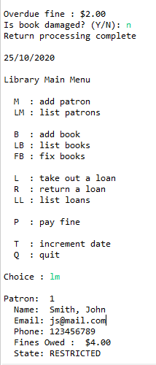

# Hypothesis 1

# Somehow the UI is mangling the fine amount of the patron when displaying the patron?

# Test 1

# Check patron in the Main class.

# Result 1

# False – the value passed isn’t mangled by the UI but mangled further back

# Conclusion 1

# Issue must be in the control class somewhere involving the fine calculation perhaps?

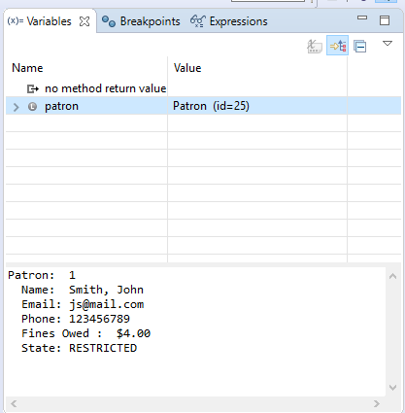

# Hypothesis 2

# Somehow overdue fine is being set to 4 before being applied to the patron?

# Test 2

# Check overdue fine just before the incurfine method is called

# Result 2

# False – fine Is 2.0

# Conclusion 2

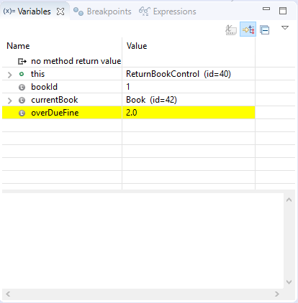

# Hypothesis 3

# The issue must be in incur fine. The fine is applied twice.

# Test 3

# Check if fine is added more than once? Check Patron’s fines payable if it shows $4.00

# Result 3

# False – fine is only added once.

# Conclusion 3

The issue must happen later in the return book process.

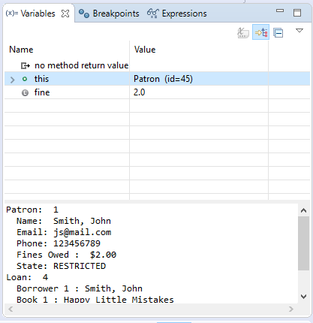

# Hypothesis 4

# The double fine issue happens in the discharge loan method of the returnbook control class.

# Test 4

# Check patron’s fines payable before the library.dischargeLoan call.

# Result 4

# False – the fine is not mangled in the discharge loan method of the returnbook control class so far

# Conclusion 4

Must be further along still.

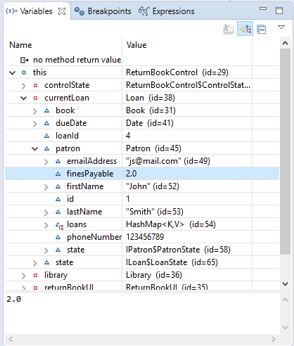

# Hypothesis 5

# The double fine issue happens in the discharge loan method of the returnbook control class.

# Test 5

# Check patron’s fines payable after the library.dischargeLoan call.

# Result 5

# True – the fines payable is now 4.0.

# Conclusion 5

The mangling must happen in library.dischargeLoan

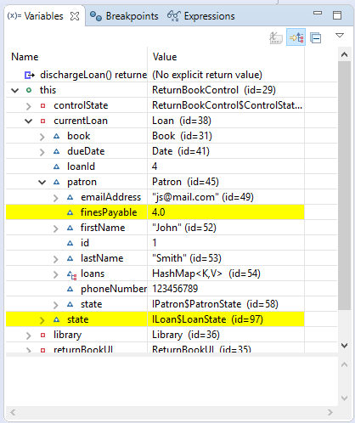

# Hypothesis 6

# The patron.incurFine method is applying the overdue fine a second time

# Test 6

# Check patron’s fines payable before and after the method

# Result 6

# True – fines payable is 4.0 after the method is run

# Conclusion 6

Nuke the entire line?

